problem-1

Create a Feedback form using HTML (With Internal CSS), it should contain

-> Name (optional)

-> Email(Optional)

-> phone (optional)

-> Rating

-> Any Questions regarding product or service.

-> Additional comments (optional)

-> Submit button

Code:

<!DOCTYPE html>

<html lang="en">

<head>

<meta charset="UTF-8">

<meta name="viewport" content="width=device-width, initial-scale=1.0">

<title>Feedback Form</title>

<style>

body {

font-family: Arial, sans-serif;

margin: 20px;

}

.form-container {

max-width: 500px;

margin: 0 auto;

padding: 20px;

border: 1px solid #ccc;

border-radius: 10px;

background-color: #f9f9f9;

}

.form-container h2 {

text-align: center;

margin-bottom: 20px;

}

.form-group {

margin-bottom: 15px;

}

.form-group label {

display: block;

margin-bottom: 5px;

font-weight: bold;

}

.form-group input, .form-group textarea, .form-group select, .form-group button {

width: 100%;

padding: 10px;

border: 1px solid #ccc;

border-radius: 5px;

box-sizing: border-box;

}

.form-group button {

background-color: #4CAF50;

color: white;

font-size: 16px;

cursor: pointer;

}

.form-group button:hover {

background-color: #45a049;

}

</style>

</head>

<body>

<div class="form-container">

<h2>Feedback Form</h2>

<form action="#" method="post">

<div class="form-group">

<label for="name">Name (Optional):</label>

<input type="text" id="name" name="name" placeholder="Your Name">

</div>

<div class="form-group">

<label for="email">Email (Optional):</label>

<input type="email" id="email" name="email" placeholder="Your Email">

</div>

<div class="form-group">

<label for="phone">Phone (Optional):</label>

<input type="tel" id="phone" name="phone" placeholder="Your Phone Number">

</div>

<div class="form-group">

<label for="rating">Rating:</label>

<select id="rating" name="rating" required>

<option value="">-- Select Rating --</option>

<option value="5">Excellent</option>

<option value="4">Good</option>

<option value="3">Average</option>

<option value="2">Poor</option>

<option value="1">Very Poor</option>

</select>

</div>

<div class="form-group">

<label for="questions">Questions regarding product or service:</label>

<textarea id="questions" name="questions" rows="4" placeholder="Write your questions here..."></textarea>

</div>

<div class="form-group">

<label for="comments">Additional Comments (Optional):</label>

<textarea id="comments" name="comments" rows="4" placeholder="Write your comments here..."></textarea>

</div>

<div class="form-group">

<button type="submit">Submit</button>

</div>

</form>

</div>

</body>

</html>

Output:

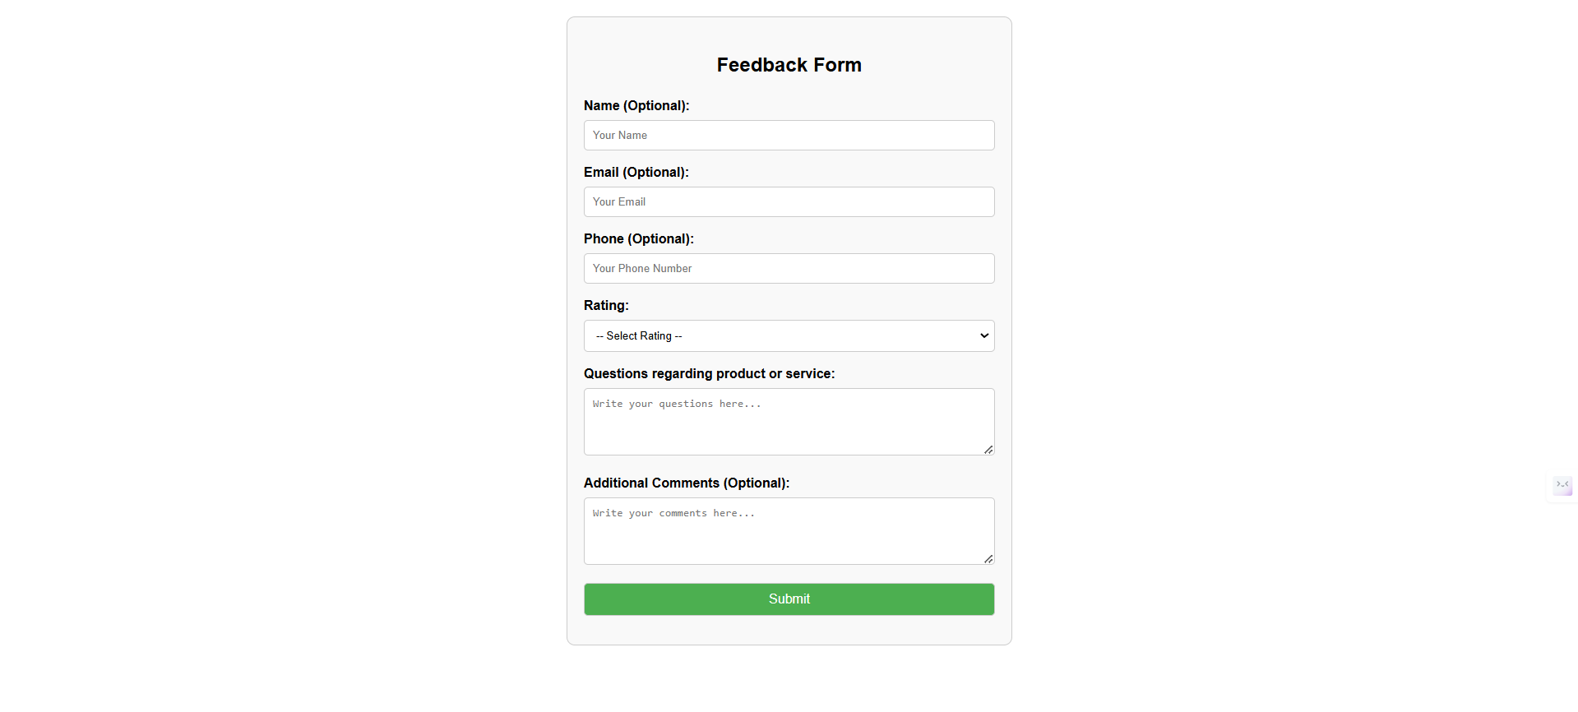

Github link: <https://github.com/MohammedObaidUllah/FEWD/blob/main/feedback2.html>

Problem-2

update a Portfolio page using internal CSS , it should contain

-> Self introduction

-> skills

-> projects/work experiences (Git links)

-> Feedback /achivements

-> Education profile

-> Contact information.(Social media /phone /email)

Note: add Internal CSS

Code:

<!DOCTYPE html>

<html lang="en">

<head>

<meta charset="UTF-8">

<meta name="viewport" content="width=device-width, initial-scale=1.0">

<title>Portfolio</title>

<style>

body {

font-family: Arial, sans-serif;

margin: 0;

padding: 0;

line-height: 1.6;

background-color: #f4f4f4;

}

header {

background: #333;

color: #fff;

padding: 20px 0;

text-align: center;

}

header h1 {

margin: 0;

}

section {

margin: 20px;

padding: 20px;

background: #fff;

border-radius: 8px;

box-shadow: 0 2px 4px rgba(0, 0, 0, 0.1);

}

section h2 {

border-bottom: 2px solid #333;

padding-bottom: 10px;

}

ul {

list-style: none;

padding: 0;

}

ul li {

margin-bottom: 10px;

}

a {

color: #333;

text-decoration: none;

}

a:hover {

color: #007BFF;

}

footer {

text-align: center;

margin-top: 20px;

padding: 10px;

background: #333;

color: #fff;

}

</style>

</head>

<body>

<header>

<h1>Welcome to My Portfolio</h1>

</header>

<section id="introduction">

<h2>Self Introduction</h2>

<p>Hello! My name is Mohammed ObaidUllah. I am a passionate Web Developer. I love working on innovative projects and learning new skills.</p>

</section>

<section id="skills">

<h2>Skills</h2>

<ul>

<li>Programming Languages: C, C++, Python, Java.</li>

<li>Web Development: HTML, CSS, JavaScript, Bootstrap.</li>

<li>Database Management: MySQL, MongoDB.</li>

<li>Other Skills: Problem Solving, Team Collaboration.</li>

</ul>

</section>

<section id="projects">

<h2>Projects / Work Experiences</h2>

<ul>

<li><a href="[GitHub Link 1]">Personal Portfolio Website</a> - Designed and developed a responsive portfolio website to showcase my skills, projects, and contact information using HTML, CSS, and JavaScript.</li>

<li><a href="[GitHub Link 2]">Task Management App</a> - Built a full-stack web application to manage daily tasks, including features like adding, editing, and deleting tasks, with MongoDB, Express.js, and Node.js.</li>

<li><a href="[GitHub Link 3]">E-commerce Platform</a> - Created a simple e-commerce platform for small businesses, allowing users to browse products, add them to a cart, and checkout, using React and Firebase.</li>

<li><a href="[GitHub Link 4]">Weather App</a> - Developed a weather application that displays real-time weather data for any city using the OpenWeatherMap API and vanilla JavaScript.</li>

<li><a href="[GitHub Link]">GitHub Repository</a> - A link to my GitHub repository for all projects.</li>

</ul>

</section>

<section id="feedback">

<h2>Feedback / Achievements</h2>

<ul>

<li>Awarded "Best Innovative Project" for the Task Management App during Marathon 151.</li>

<li>Successfully completed a professional certification in Python.</li>

<li>Received excellent feedback from clients for developing user-friendly and robust applications.</li>

</ul>

</section>

<section id="education">

<h2>Education Profile</h2>

<ul>

<li><strong>Keshav Memorial Institute of Technology</strong>

<p>B.Tech in Computer Science and Engineering - CGPA: 8.85/10</p>

</li>

<li><strong>MS Junior College</strong>

<p>11-12 SSC: 940/1000</p>

</li>

<li><strong>Ravindra Bharathi School</strong>

<p>SSC (Secondary School Certificate) - GPA: 9/10</p>

</li>

</ul>

</section>

<section id="contact">

<h2>Contact Information</h2>

<p>Email: <a href="mailto:mohammedobaidullah2004@gmail.com">mohammedobaidullah2004@gmail.com</a></p>

<p>Phone: <a href="tel:+9391307881">+9391307881</a></p>

<p>Social Media:</p>

<ul>

<li><a href="[LinkedIn URL]">LinkedIn</a></li>

<li><a href="[Twitter URL]">Twitter</a></li>

<li><a href="[GitHub URL]">GitHub</a></li>

</ul>

</section>

<footer>

<p>&copy; 2025 Mohammed ObaidUllah. All Rights Reserved.</p>

</footer>

</body>

</html>

Output:

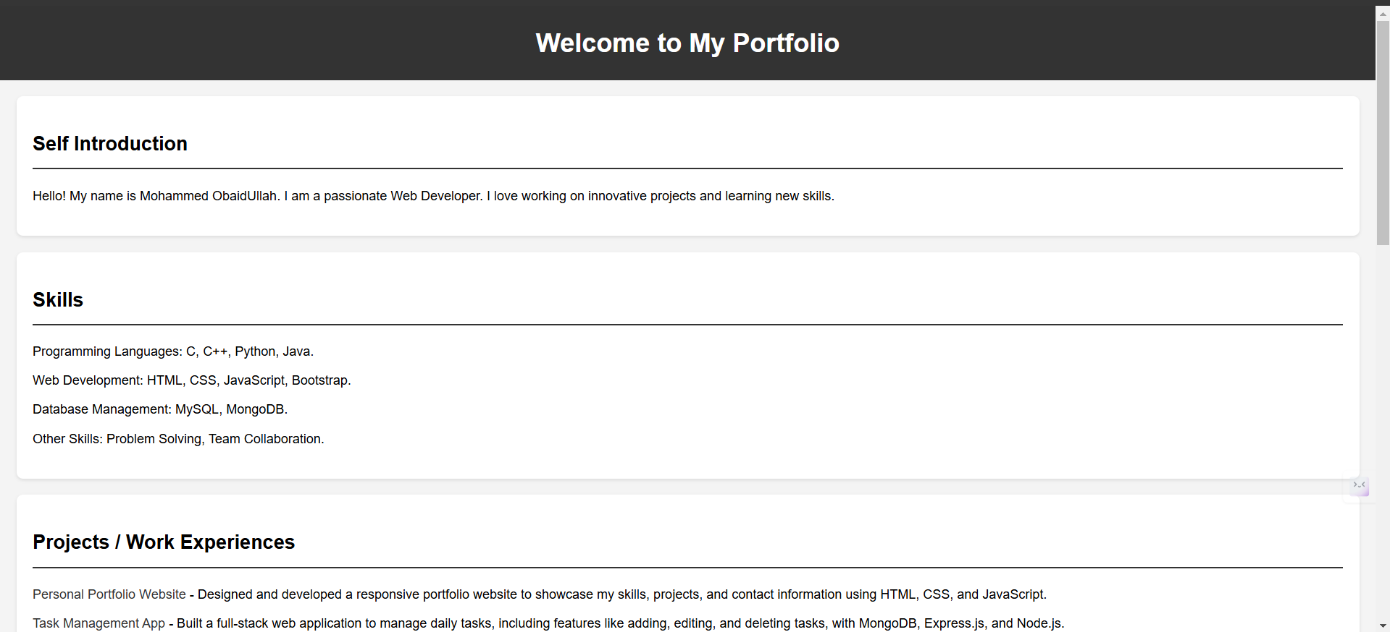

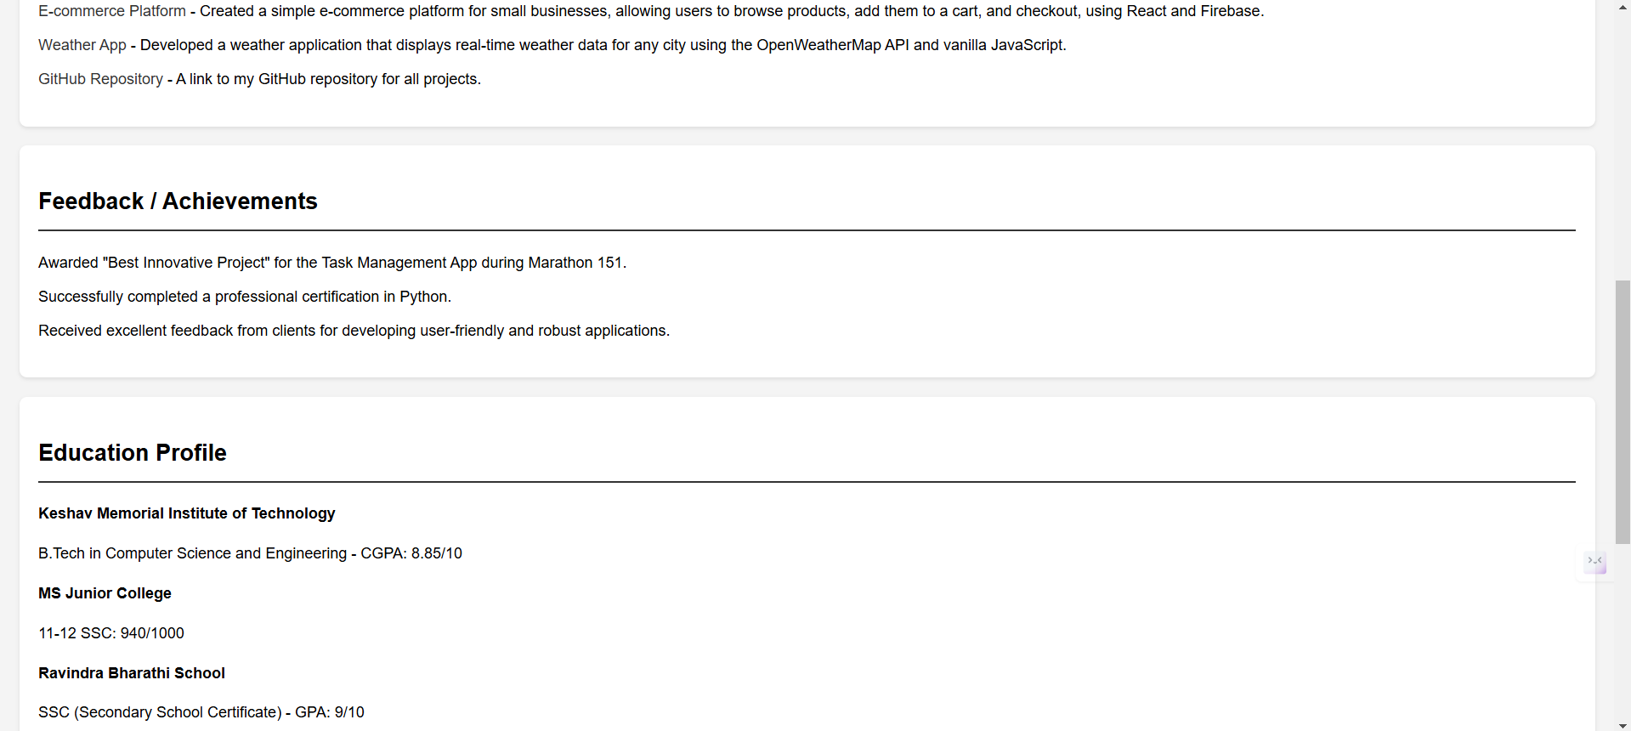

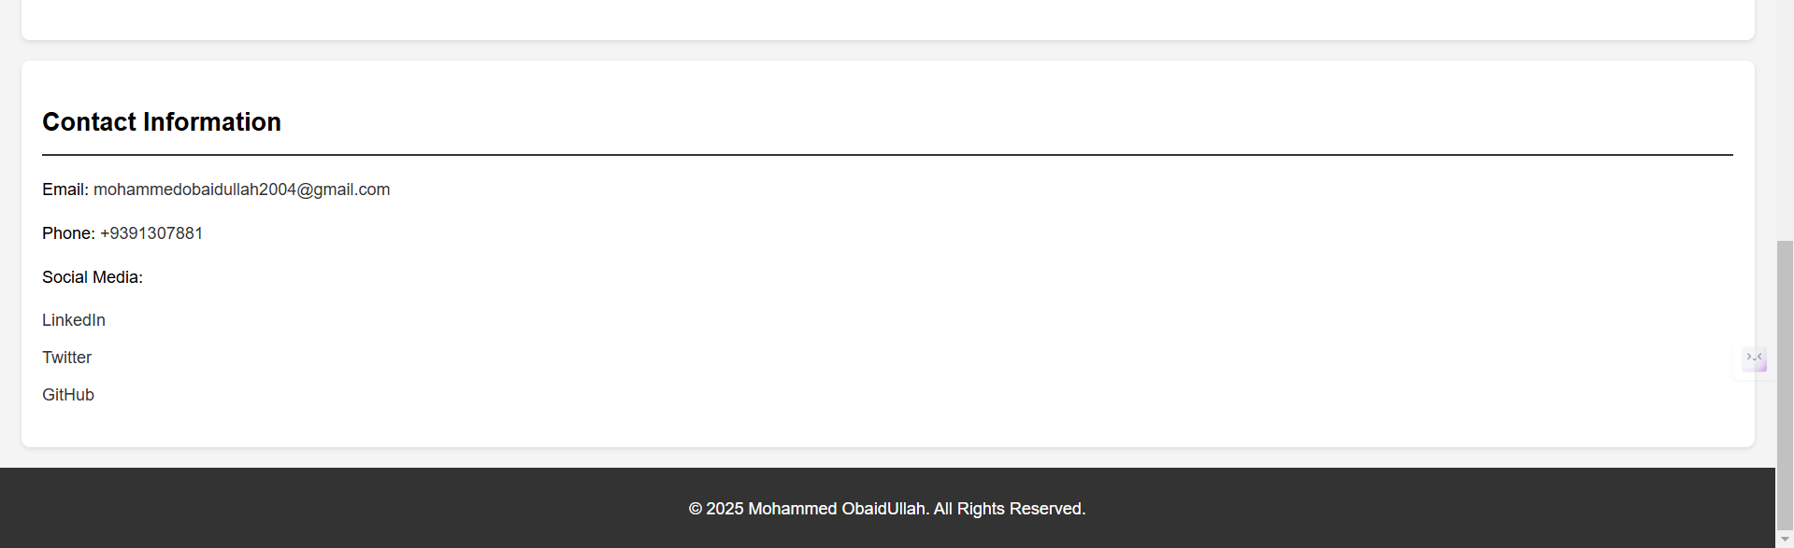

Github link: <https://github.com/MohammedObaidUllah/FEWD/blob/main/portfolio2.html>

problem-3

Update the both (feedback and portfolio) pages with external css.

Feedback: feedback1.html

<!DOCTYPE html>

<html lang="en">

<head>

<meta charset="UTF-8">

<meta name="viewport" content="width=device-width, initial-scale=1.0">

<title>Feedback Form</title>

<link rel="stylesheet" href="feedback1.css">

</head>

<body>

<div class="form-container">

<h2>Feedback Form</h2>

<form action="#" method="post">

<div class="form-group">

<label for="name">Name (Optional):</label>

<input type="text" id="name" name="name" placeholder="Your Name">

</div>

<div class="form-group">

<label for="email">Email (Optional):</label>

<input type="email" id="email" name="email" placeholder="Your Email">

</div>

<div class="form-group">

<label for="phone">Phone (Optional):</label>

<input type="tel" id="phone" name="phone" placeholder="Your Phone Number">

</div>

<div class="form-group">

<label for="rating">Rating:</label>

<select id="rating" name="rating" required>

<option value="">-- Select Rating --</option>

<option value="5">Excellent</option>

<option value="4">Good</option>

<option value="3">Average</option>

<option value="2">Poor</option>

<option value="1">Very Poor</option>

</select>

</div>

<div class="form-group">

<label for="questions">Questions regarding product or service:</label>

<textarea id="questions" name="questions" rows="4" placeholder="Write your questions here..."></textarea>

</div>

<div class="form-group">

<label for="comments">Additional Comments (Optional):</label>

<textarea id="comments" name="comments" rows="4" placeholder="Write your comments here..."></textarea>

</div>

<div class="form-group">

<button type="submit">Submit</button>

</div>

</form>

</div>

</body>

</html>

Github link: <https://github.com/MohammedObaidUllah/FEWD/blob/main/feedback1.html>

Css: feedback1.css

body {

font-family: Arial, sans-serif;

margin: 20px;

}

.form-container {

max-width: 500px;

margin: 0 auto;

padding: 20px;

border: 1px solid #ccc;

border-radius: 10px;

background-color: #f9f9f9;

}

.form-container h2 {

text-align: center;

margin-bottom: 20px;

}

.form-group {

margin-bottom: 15px;

}

.form-group label {

display: block;

margin-bottom: 5px;

font-weight: bold;

}

.form-group input, .form-group textarea, .form-group select, .form-group button {

width: 100%;

padding: 10px;

border: 1px solid #ccc;

border-radius: 5px;

box-sizing: border-box;

}

.form-group button {

background-color: #4CAF50;

color: white;

font-size: 16px;

cursor: pointer;

}

.form-group button:hover {

background-color: #45a049;

}

Github link: <https://github.com/MohammedObaidUllah/FEWD/blob/main/feedback1.css>

Output:

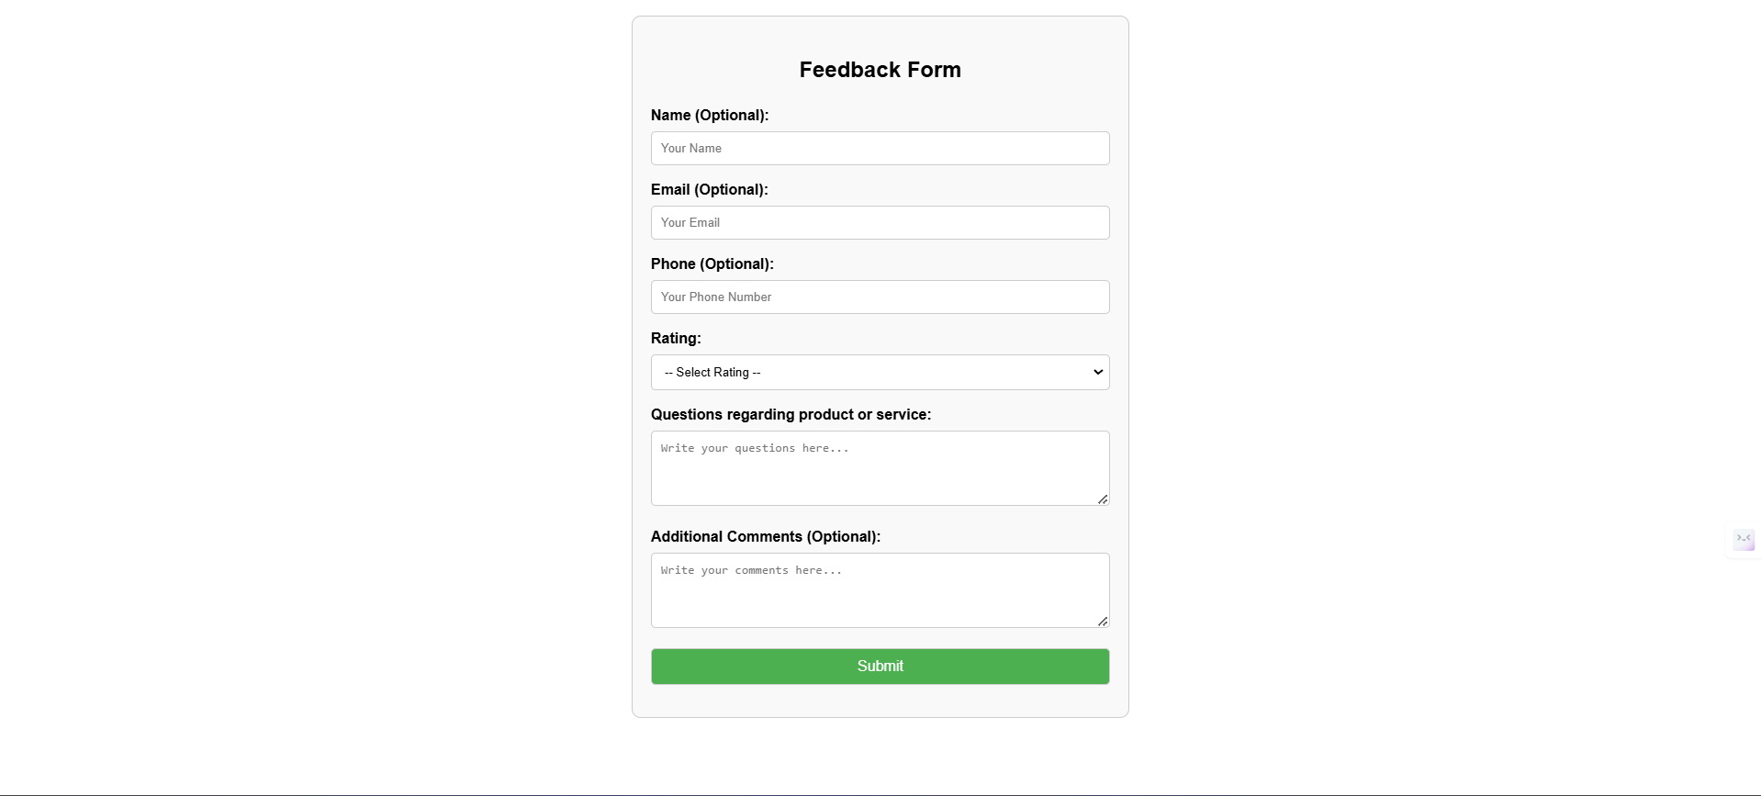

Portfolio: portfolio1.html

<!DOCTYPE html>

<html lang="en">

<head>

<meta charset="UTF-8">

<meta name="viewport" content="width=device-width, initial-scale=1.0">

<title>Portfolio</title>

<link rel="stylesheet" href="portfolio1.css">

</head>

<body>

<header>

<h1>Welcome to My Portfolio</h1>

</header>

<section id="introduction">

<h2>Self Introduction</h2>

<p>Hello! My name is Mohammed ObaidUllah. I am a passionate Web Developer. I love working on innovative projects and learning new skills.</p>

</section>

<section id="skills">

<h2>Skills</h2>

<ul>

<li>Programming Languages: C, C++, Python, Java.</li>

<li>Web Development: HTML, CSS, JavaScript, Bootstrap.</li>

<li>Database Management: MySQL, MongoDB.</li>

<li>Other Skills: Problem Solving, Team Collaboration.</li>

</ul>

</section>

<section id="projects">

<h2>Projects / Work Experiences</h2>

<ul>

<li><a href="[GitHub Link 1]">Personal Portfolio Website</a> - Designed and developed a responsive portfolio website to showcase my skills, projects, and contact information using HTML, CSS, and JavaScript.</li>

<li><a href="[GitHub Link 2]">Task Management App</a> - Built a full-stack web application to manage daily tasks, including features like adding, editing, and deleting tasks, with MongoDB, Express.js, and Node.js.</li>

<li><a href="[GitHub Link 3]">E-commerce Platform</a> - Created a simple e-commerce platform for small businesses, allowing users to browse products, add them to a cart, and checkout, using React and Firebase.</li>

<li><a href="[GitHub Link 4]">Weather App</a> - Developed a weather application that displays real-time weather data for any city using the OpenWeatherMap API and vanilla JavaScript.</li>

<li><a href="[GitHub Link]">GitHub Repository</a> - A link to my GitHub repository for all projects.</li>

</ul>

</section>

<section id="feedback">

<h2>Feedback / Achievements</h2>

<ul>

<li>Awarded "Best Innovative Project" for the Task Management App during Marathon 151.</li>

<li>Successfully completed a professional certification in Python.</li>

<li>Received excellent feedback from clients for developing user-friendly and robust applications.</li>

</ul>

</section>

<section id="education">

<h2>Education Profile</h2>

<ul>

<li><strong>Keshav Memorial Institute of Technology</strong>

<p>B.Tech in Computer Science and Engineering - CGPA: 8.85/10</p>

</li>

<li><strong>MS Junior College</strong>

<p>11-12 SSC: 940/1000</p>

</li>

<li><strong>Ravindra Bharathi School</strong>

<p>SSC (Secondary School Certificate) - GPA: 9/10</p>

</li>

</ul>

</section>

<section id="contact">

<h2>Contact Information</h2>

<p>Email: <a href="mailto:mohammedobaidullah2004@gmail.com">mohammedobaidullah2004@gmail.com</a></p>

<p>Phone: <a href="tel:+9391307881">+9391307881</a></p>

<p>Social Media:</p>

<ul>

<li><a href="[LinkedIn URL]">LinkedIn</a></li>

<li><a href="[Twitter URL]">Twitter</a></li>

<li><a href="[GitHub URL]">GitHub</a></li>

</ul>

</section>

<footer>

<p>&copy; 2025 Mohammed ObaidUllah. All Rights Reserved.</p>

</footer>

</body>

</html>

Github link: <https://github.com/MohammedObaidUllah/FEWD/blob/main/portfolio1.html>

Css: portfolio1.css

body {

font-family: Arial, sans-serif;

line-height: 1.6;

margin: 0;

padding: 0;

background-color: #f4f4f9;

color: #333;

}

header {

background: #333;

color: #fff;

padding: 10px 0;

text-align: center;

}

h1 {

margin: 0;

}

section {

margin: 20px;

padding: 20px;

background: #fff;

border-radius: 10px;

box-shadow: 0 0 10px rgba(0, 0, 0, 0.1);

}

h2 {

color: #444;

border-bottom: 2px solid #f4f4f9;

padding-bottom: 5px;

margin-bottom: 15px;

}

ul {

list-style: none;

padding: 0;

}

ul li {

padding: 5px 0;

}

a {

color: #0066cc;

text-decoration: none;

}

a:hover {

text-decoration: underline;

}

footer {

text-align: center;

padding: 10px 0;

background: #333;

color: #fff;

margin-top: 20px;

}

Github link: <https://github.com/MohammedObaidUllah/FEWD/blob/main/portfolio1.css>

Output:

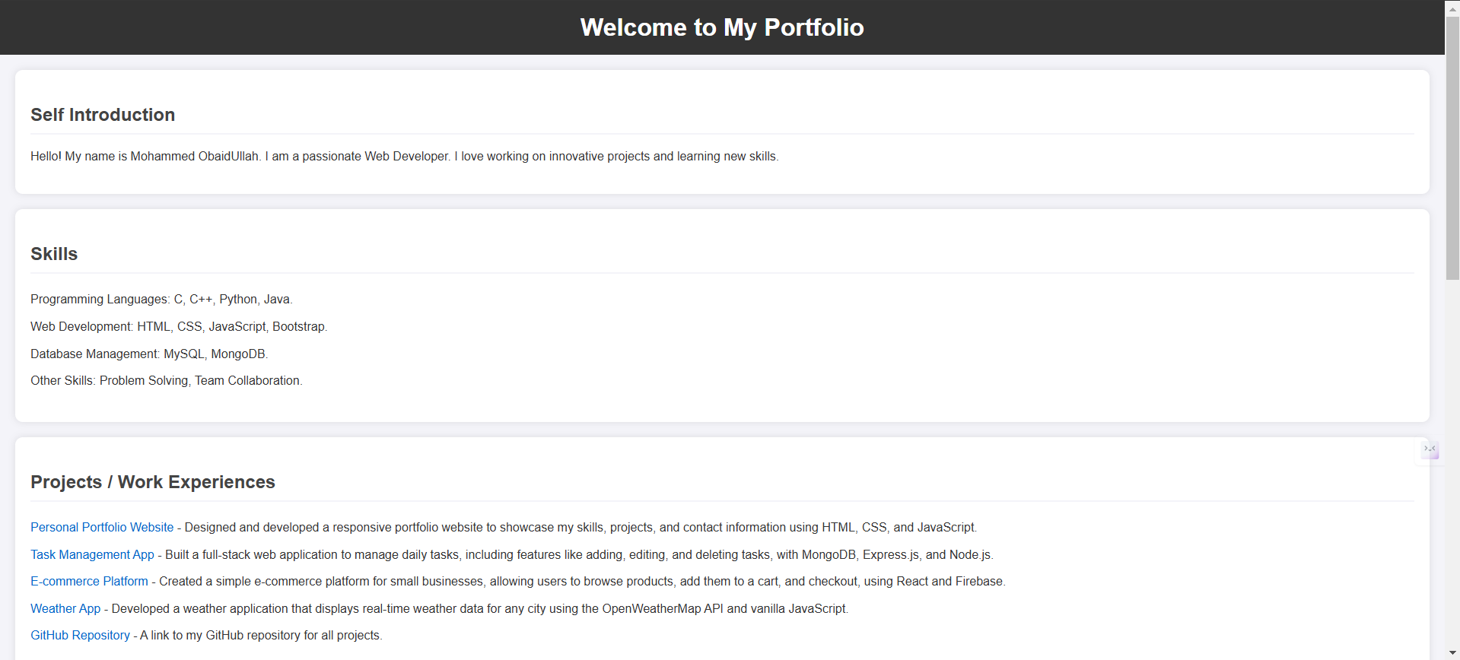

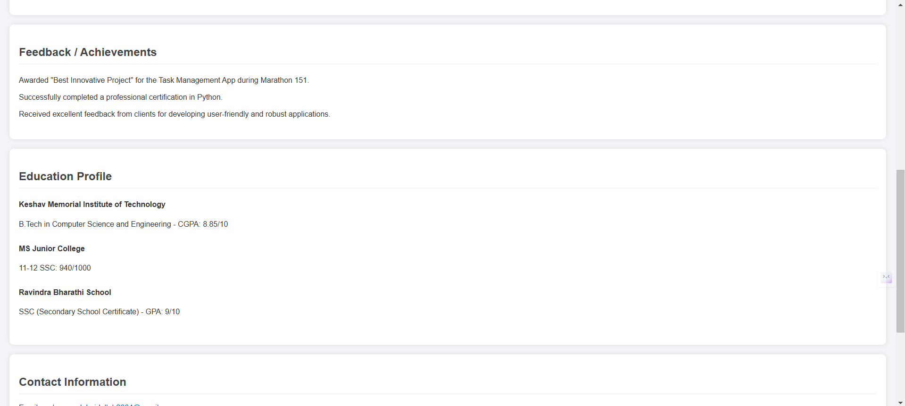

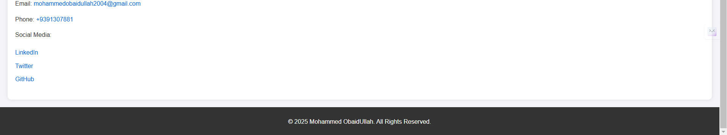

Github link for all the problems: <https://github.com/MohammedObaidUllah/FEWD>